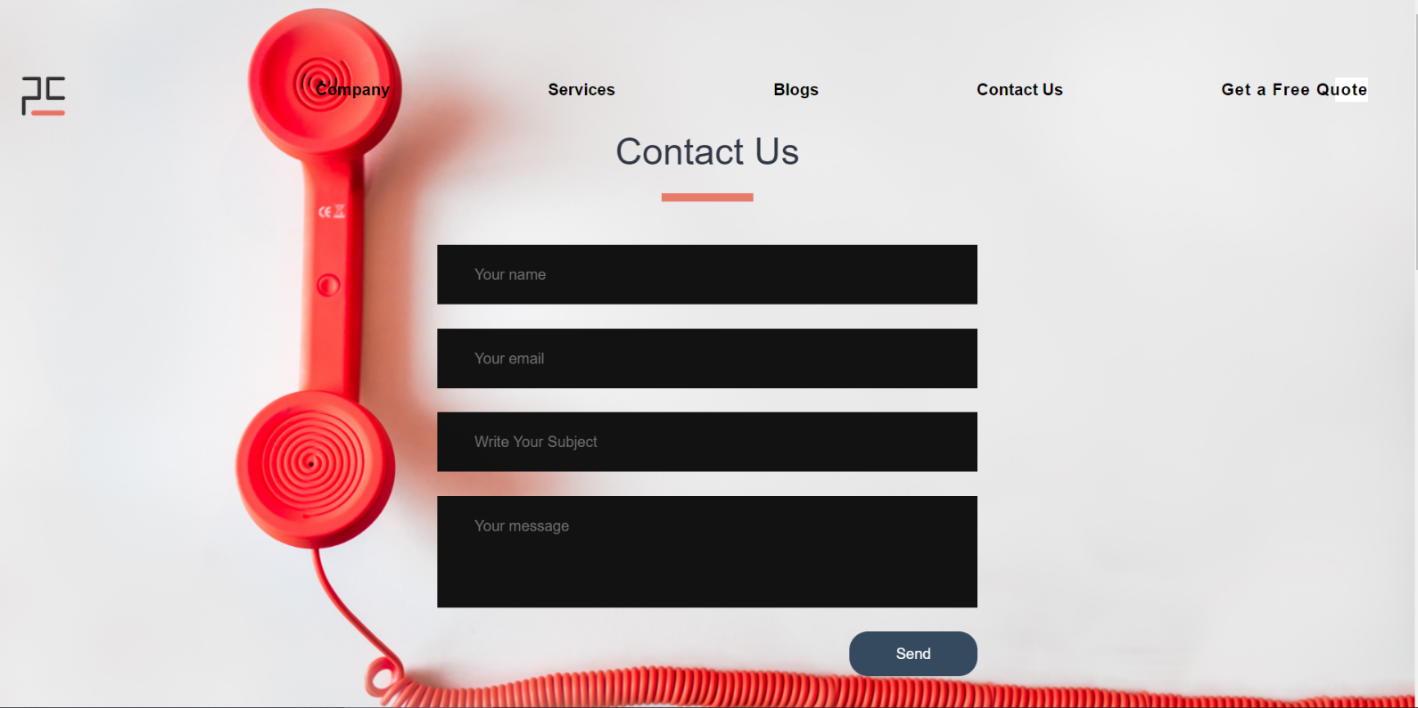**Contact Us**

|  |  |  |  |
| --- | --- | --- | --- |
| **Container** |  |  |  |
| **Part** | **Screenshot** | **Effect** | **Code** |
| Heading |  | None | Reference:  HTML: Contact_Us.html line no. 80  CSS: style_contact.css line no. 38 |
| Form |  | On Scroll every text box come from alternate direction left and right. | Reference:  HTML: Contact_Us.html line no. 82  CSS: style_contact.css  line no. 16 |

|  |  |  |  |
| --- | --- | --- | --- |
| Button |  | On hover button colour will change into brand colour. | Reference:  HTML: Contact_Us.html line no. 87  CSS: style_contact.css line no. 86 |
| Map |  | Work like google map and find company location | Reference:  HTML: Contact_Us.html line no. 91  CSS: Contact_Us.html line no. 91 |
| Contact Details |  | Come from left to right. | Reference:  HTML: Contact_Us.html line no. 96  CSS: style_contact.css line no. 90 |
| Mail Button |  | Hon hover logo colour change to white and information is visible. | Reference:  HTML: Contact_Us.html line no.98  CSS: style_contact.css line no. 128 |